St. John the Evangelist Catholic Church
10431 Twin Rivers Road
Columbia, Maryland 21044

October 17, 2018

INVITATION TO PARISH LISTENING SESSIONS

Dear Friends in Christ,

This letter is to invite you to a parish “listening session” concerning where we are in helping the larger church to respond wisely, appropriately, even urgently, to the abuse crisis engulfing our beloved Church.

To recap, at our first planning meeting on August 30, attended by about 60 parishioners, we learned that so many of us were traumatized, and we needed first a chance to be heard. After consultation with lay professionals in our parish we met again on October 4, with about 40 parishioners, essentially to be a trial run of how to conduct a “listening session” for our wider parish community. With benefit of the format of that successful meeting, again with professional consultation, parish leaders chose the size and shape of other meetings for our larger parish community.

These “open to all” sessions will be offered on three Thursdays in November: November 8,15 and 29, from 7:30 – 9:00 PM at Wilde Lake. Each session is not equipped nor intended to provide therapy, but it will be led by the professionals of our church who are skilled in facilitation of discussions.

May I ask you to please rsvp, so that we may plan appropriately? Contact my secretary mary.casey@sjerc.org, or call her at 410-964-1425 x 302. To arrange listening group size so all people can effectively be heard, we will meet in tables of 8, with a maximum of 12 tables per session. Please indicate all of the dates that you are able to attend, and your preferred date, then we will confirm your actual session date.

We will schedule as many sessions as needed to hear from everyone who wishes to participate. The comments or suggested actions to help us repair our Church which come from these tables will be shared with the entire group as part of each listening session. Lay leaders of the parish will be tasked with using these table reports to inform our parish’s future steps in continuing to actively respond to this crisis of sexual abuse, and abuse of power.

I look forward to our being together, this time, with expectation of our taking the time to hear from one another. I want to thank each of you for your commitment to helping our parish, and our larger Church engage in the work of healing and reformation for the People of God, the Body of Christ.

In the Peace of Christ,

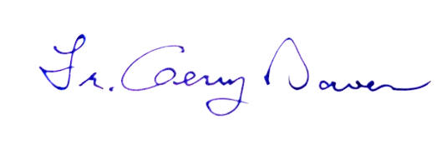

Fr. Gerry Bowen

