SHARE IN ASP
2021
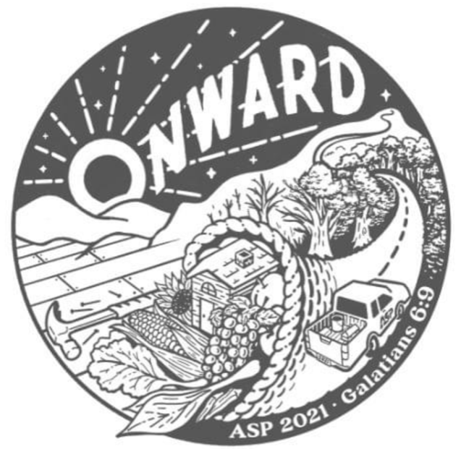

“Let’s not get tired of doing good, because in time we’ll have a harvest if we don’t give up.” Galatians 6:9

We need all ASP, those going on the trip and those participating at home to sell $100 in Shares.

You have each made a commitment to do God’s work this summer in Appalachia and Howard County. PLEASE ASK your relatives and friends to SHARE this commitment.

Send them an email or letter explaining why you have chosen to volunteer, and how their donation will help provide a family with a dry roof that does not leak…a bedroom that is warm, not wet or damp…a wheelchair ramp that is safe for a disabled person…a front porch to sit on and relax…a foundation for their home that will not collapse…and so much more!

We ask each volunteer to raise at least $100. All sales will be done electronically this year! We are not able to accept cash donations this year. There are two ways to donate:

- Donation via check
  - Checks should be made payable to St. John the Evangelist Catholic Church and sent to Lynda Allera (10912 Beech Creek Drive, Columbia, MD 21044). In the Memo line, please write “ASP Summer Support”

- Donation via the Give Central website.
  - Donors can visit the following website: https://www.givecentral.org/location/501/events-list-basic
  - Once there, they can check the box next to “ASP Summer Support”, “one-time payment” and the amount they wish to donate. Then they can scroll to the bottom, click “Add to my gift basket” and follow the instructions to complete the donation payment.

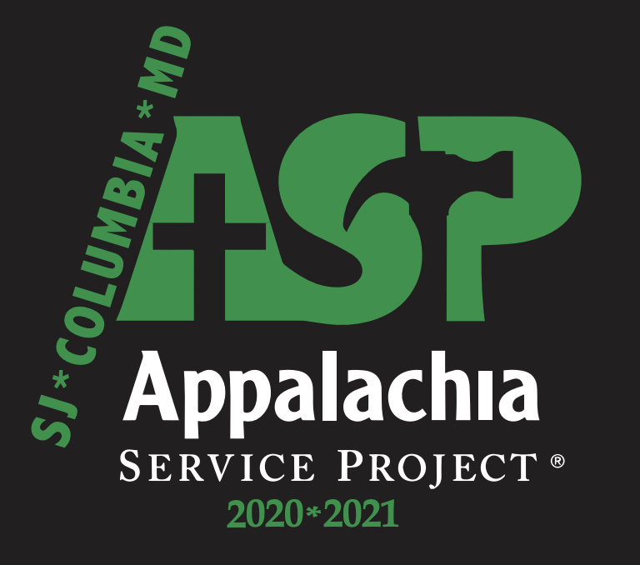

Other important information to remember:

- If any of your donors would like a receipt, please complete the attached “Share in ASP Order Form” and send it to the donor. Their donation is 100% tax deductible.

- If any of your donors would like a certificate with a picture, please send their name, address, and the amount of the donation to ritacole37@gmail.com. I will mail them the certificate.

- Keep a record of any donations $100.00 or more by emailing the donor’s name and address to ritacole37@gmail.com

Finally, send a personalized THANK YOU note to each donor and invite them to attend the ASP Service when we return from the trip (July 25).

THANK YOU!!!!!!!!

Rita Cole
ritacole37@gmail.com

